Appendix 1
21/00317/FUL WIC House, Transport Way
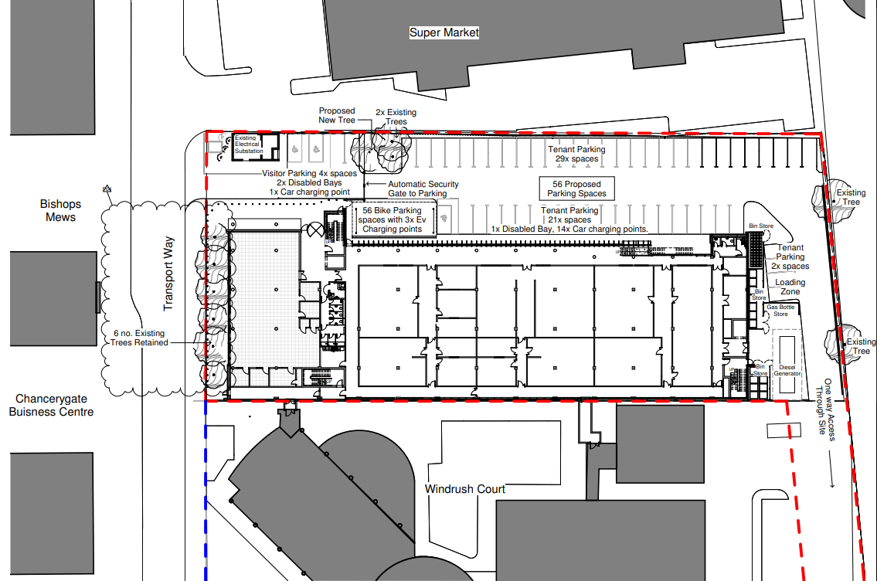
Proposed block plan

